**TINKER CARD OUTPUT:-**

1.We can alter the amount of water to be sent to the fields and it would be working as per the requirement of the crop and soil. It also helps the farmer in preventing the crops from getting destroyed because of stray cattle or birds.

Here we have explored the arena of how computer programming can make our jobs easy and much reliable. The system has a provision for a closed-loop control of the water supply to realize a fully autonomous irrigation scheme. It describes the system and discusses in detail the information processing results of three weeks data based on the proposed algorithm. The system is fully functional and the prediction results are very encouraging.

It is very clear that as soon as any animal or any harmful object comes in the vicinity of the crops the buzzer immediately starts ringing thus alarming the farmer and scaring the animal at the same time. A Proximity sensor comes into action here.

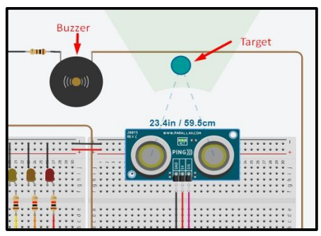

Working of Proximity Sensor

2. This is a Potentiometer in action that detects the amount of water in the soil and based on programmed values the moment the water level goes below the mentioned value the light turns Red and this is an indication for the motor to start and thus optimised irrigation will happen. As soon as the water content will be optimum the light will turn green/blue and hence the motor will stop.

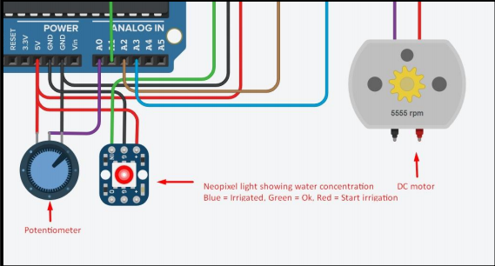

Working of Potentiometer

the diagram below the light is blue hence the motor is off thus serving our aim in this project.

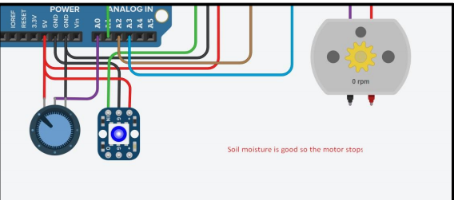

Potentiometer when water level is optimum

3. The LDR sensor here measures the amount of light falling on the crops and attached to it an indicator LED that will glow letting the farmer know if the sunlight is sufficient or not.

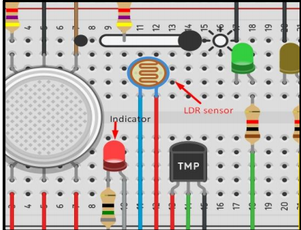

Working of LDR Sensor

Similarly, a Temperature sensor that checks the ideal temperature for the crops and alarms the farmer accordingly. This is a really great feature for better generation of crops.

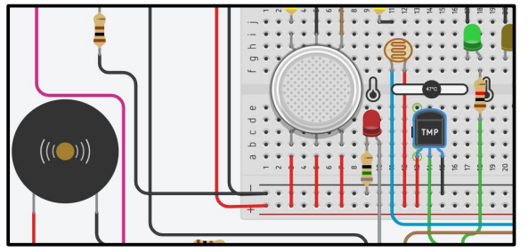

Working of Temperature Sensor

Given below is an example of ideal temperature conditions when the value is around 27 °C.

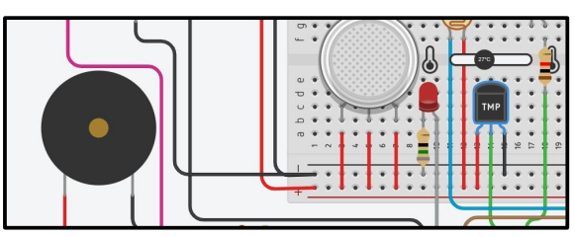

Temperature sensor when temperature is ideal

4. Given below is a demonstration of Gas Sensor that maintains the level of healthy gases for the crops and if there are any harmful gases around the indicator LEDs connected to it notify the farmer about any anomaly and besides that there is a buzzer connected to this circuit that will also notify the farmer.

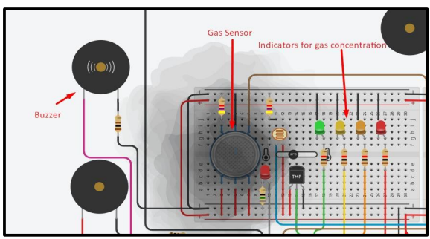

Working of Gas Sensor